**PRACTICAL NO:- 10**

The Logistic Regression is a regression model in which the response variable (dependent variable) has categorical values such as True/False or 0/1. It actually measures the probability of a binary response as the value of response variable based on the mathematical equation relating it with the predictor variables.

The general mathematical equation for logistic regression is ->

**y = 1/(1+e^-(a+b1x1+b2x2+b3x3+...))**

Following is the description of the parameters used ->

* y is the response variable
* x is the predictor variable.
* a and b are the coefficients which are numeric constants.
* The function used to create the regression model is the glm() function.

**Syntax:-**

The basic syntax for glm() function in logistic regression is ->

glm(formula,data,family)

Following is the description of the parameters used -

formula is the symbol presenting the relationship between the variables.

data is the data set giving the values of these variables.

family is R object to specify the details of the model. It's value is binomial for logistic regression.

**Example:-**

The in-built data set "mtcars" describes different models of a car with their various engine specifications. In "mtcars" data set, the transmission mode (automatic or manual) is described by the column am which is a binary value (0 or 1). We can create a logistic regression model between the columns "am" and 3 other columns - hp, wt and cyl.

**Open new script in R and type the code.**

**Code:-**

input <- mtcars[,c("am","cyl","hp","wt")]

print(head(input))

input <- mtcars[,c("am","cyl","hp","wt")]

am.data = glm(formula = am ~ cyl + hp + wt, data = input, family = binomial)

print(summary(am.data))

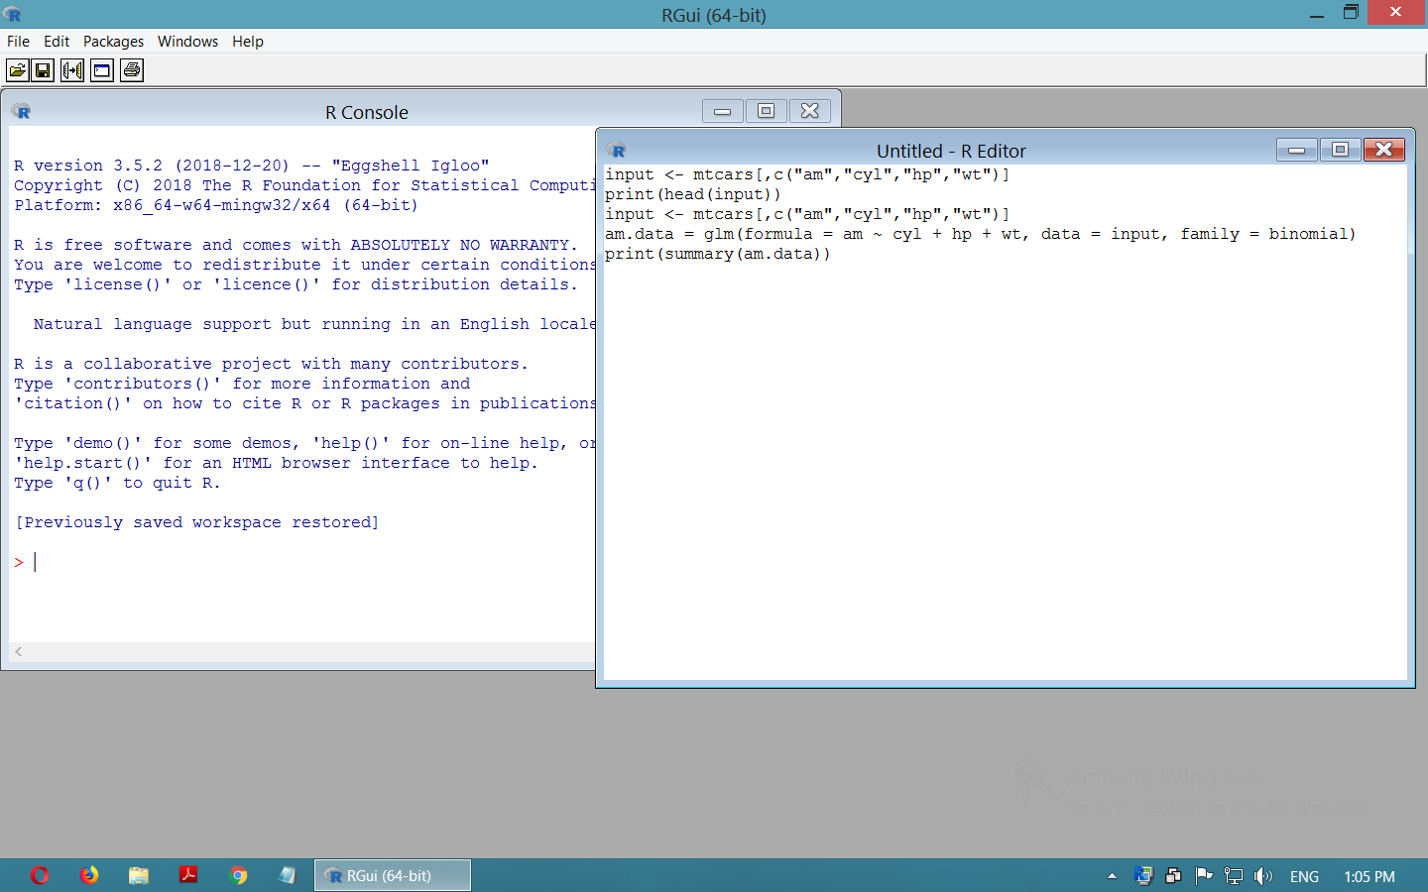

**Now, select the code and press F5.**

**Output:-**

